Task 9: Credit Card Fraud Detection Using Random Forest

1. Objective
The objective of this task is to build a machine learning model that can detect fraudulent credit card transactions using the Random Forest algorithm. Since fraud datasets are highly imbalanced, appropriate evaluation metrics such as precision, recall, and F1-score are used instead of accuracy.

2. Dataset Description
The dataset used for this project is the Kaggle Credit Card Fraud Detection Dataset.
- The dataset contains transactions made by European cardholders.
- It consists of numerical features obtained after PCA transformation.
- The target column is Class:
  - 0 → Non-Fraudulent transaction
  - 1 → Fraudulent transaction
- The dataset is highly imbalanced, with very few fraud cases compared to normal transactions.

3. Tools and Technologies Used
- Python
- Pandas
- Scikit-learn
- Matplotlib
- Google Colab / Jupyter Notebook

4. Data Preprocessing
The dataset was loaded using Pandas. The target variable (Class) was separated from the feature set.
A stratified train-test split was performed to ensure that the proportion of fraud and non-fraud cases remained the same in both training and testing datasets.

5. Handling Class Imbalance
Since fraudulent transactions are rare, accuracy is not a reliable metric.
To handle class imbalance:
- Stratified sampling was used.
- Evaluation focused on precision, recall, and F1-score.
- Random Forest was trained with class_weight='balanced'.

6. Baseline Model: Logistic Regression
A Logistic Regression model was trained as a baseline to compare performance.
- It provides a simple linear approach.
- Performance was evaluated using classification metrics.
- Results showed limitations in detecting fraud due to imbalance.

7. Random Forest Model
Random Forest is an ensemble learning method that combines multiple decision trees to improve prediction accuracy and robustness.
Model Parameters:
- Number of trees (n_estimators): 100
- Class weight: Balanced
- Random state: Fixed for reproducibility
The Random Forest model performed significantly better than Logistic Regression in detecting fraudulent transactions.

8. Model Evaluation
The model was evaluated using the following metrics:
- Precision
- Recall
- F1-Score
- Confusion Matrix
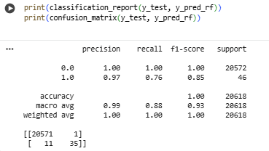
Recall for fraud cases was given high importance, as correctly identifying fraudulent transactions is critical.

9. Feature Importance Analysis

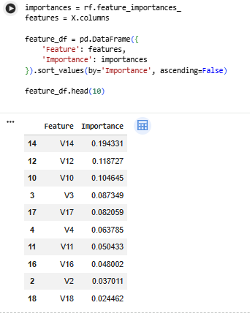
Random Forest provides feature importance scores, which help identify the most influential features contributing to fraud detection.
This improves interpretability and helps understand which transaction patterns are suspicious.

10. Results and Discussion
- Random Forest outperformed Logistic Regression.
- The model achieved better recall and F1-score for fraud detection.
- Feature importance analysis highlighted key fraud indicators.
- The approach effectively handles imbalanced data.
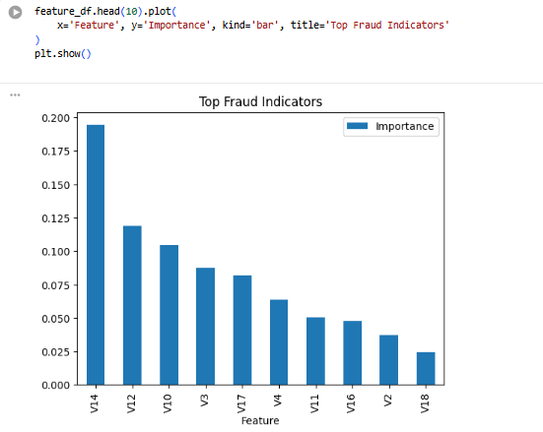

11. Conclusion
This task successfully demonstrated the application of Random Forest for credit card fraud detection. The model handled class imbalance effectively and provided reliable predictions. Using appropriate evaluation metrics ensured meaningful performance assessment.

12. Future Scope
- Implement advanced models such as XGBoost or LightGBM.
- Apply SMOTE for better class balance.
- Perform hyperparameter tuning.
- Deploy the model using a web application.

